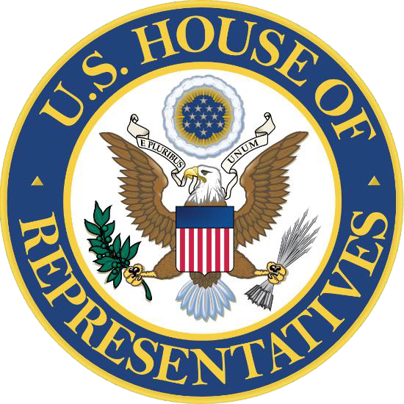

U.S. REPRESENTATIVE SEAN CASTEN IL 06 UNITED STATES SERVICE ACADEMY 2025 PRIVACY ACT RELEASE FORM

**Please read before signing** I certify that I am a resident of the 6th Congressional District of Illinois. I also understand that if I have not submitted all the necessary information and do not have an open admissions file with an academy as of 30 November 2023, I will not be given consideration for a nomination.

In the event that the Office of Congressman Sean Casten finds it necessary to make inquiries on your behalf concerning your nomination, it is important that you provide permission for such inquiries to be made.

Please PRINT your name:

Date of birth (dd/mm/yyyy):

SSN:

I hereby authorize the Office of Congressman Sean Casten to make an inquiry on my behalf to obtain all necessary information related to a United States Service Academy nomination.

**Signature of Applicant Date**